**VPC – Assignment**

**Production Network:**

1. Design and build a 4-tier architecture.

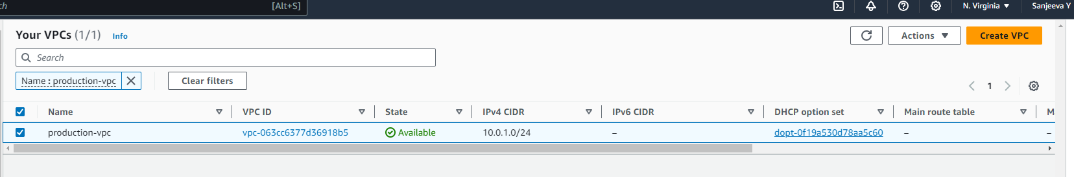

2. Create 5 subnets out of which 4 should be private named app1, app2, dbcache and db and one should be public, named web.

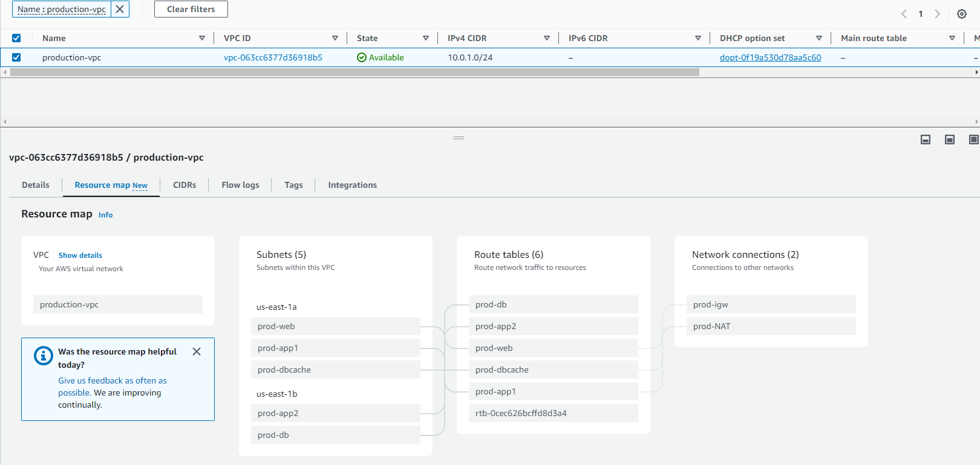

3. Launch instances in all subnets and name them as per the subnet that they have been launched in.

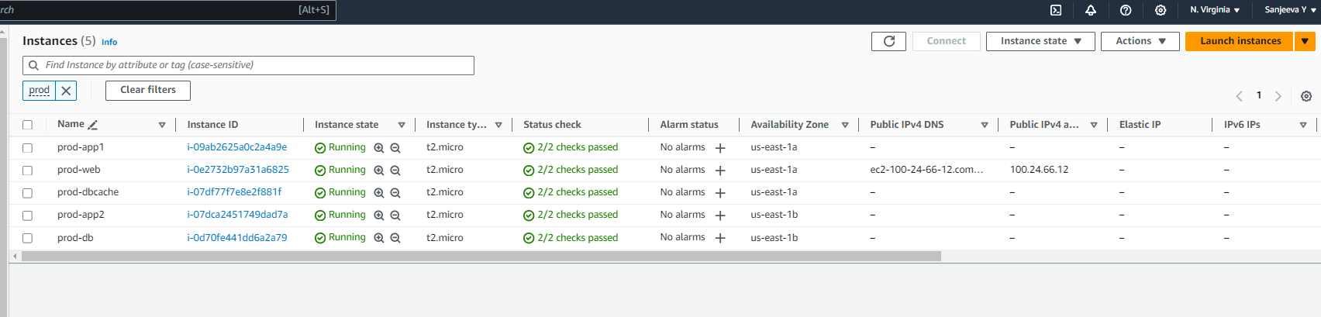

4. Allow dbcache instance and app1 subnet to send internet requests.

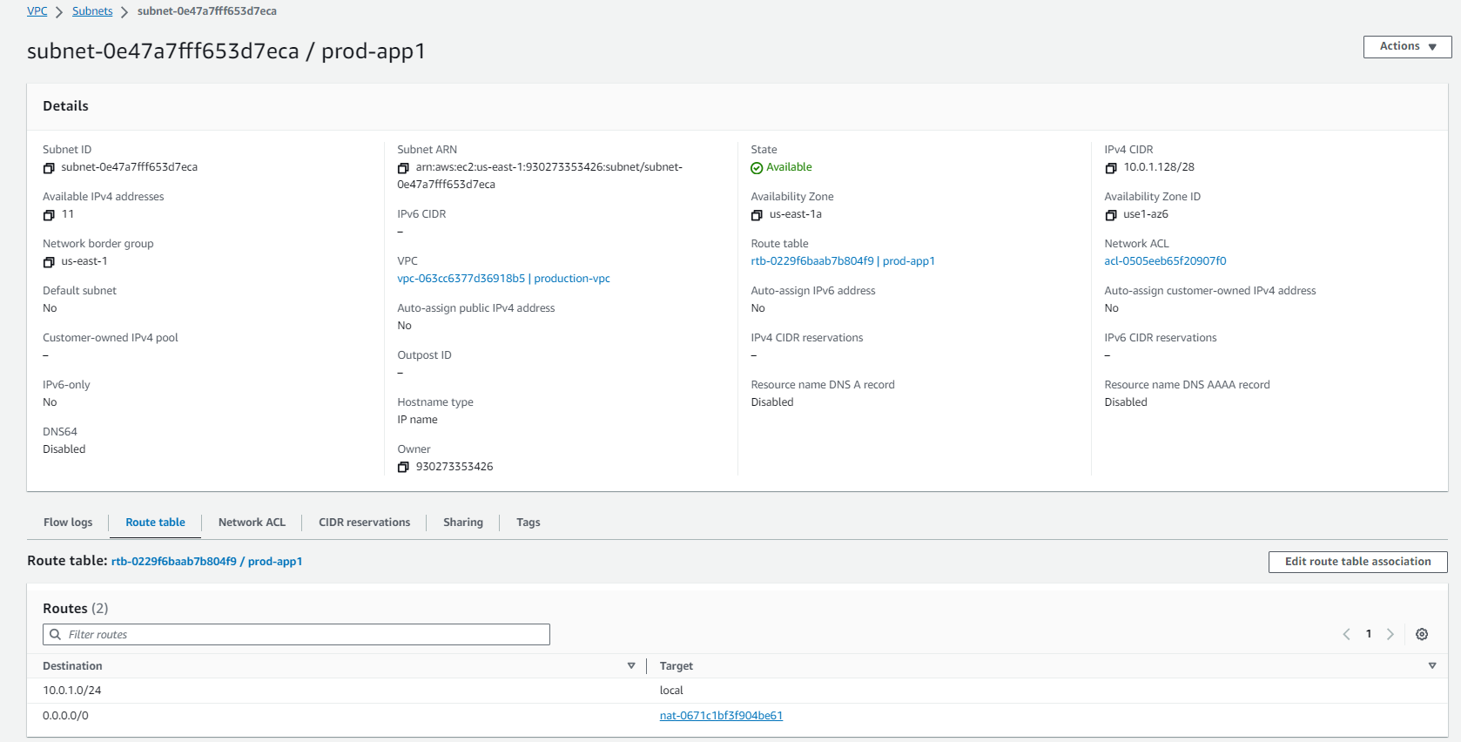

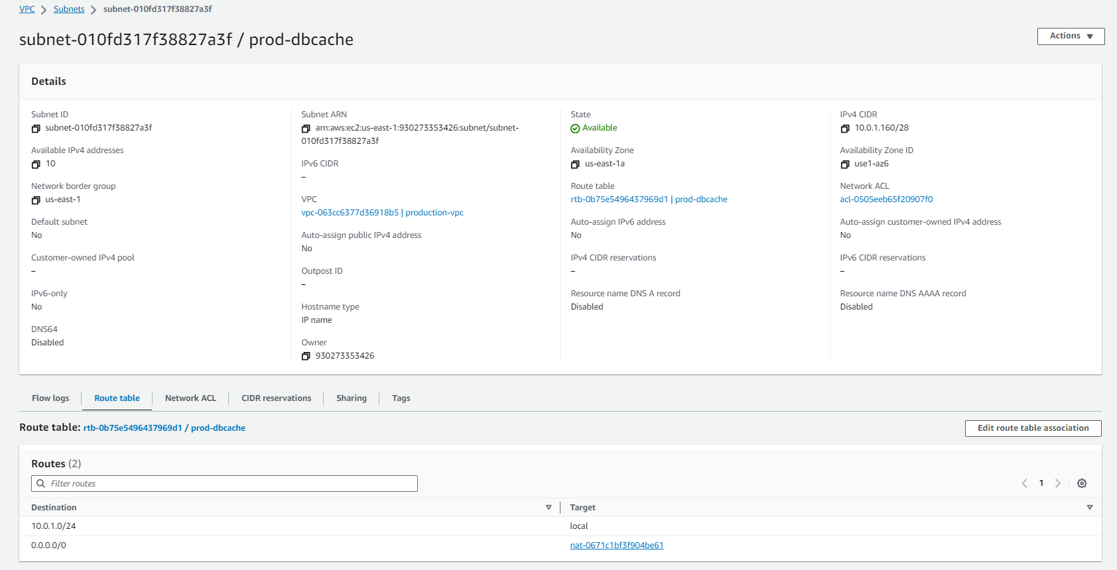

5. Manage security groups and NACLs.

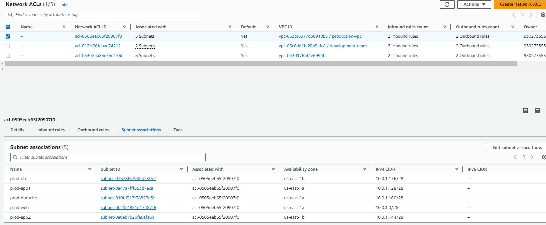

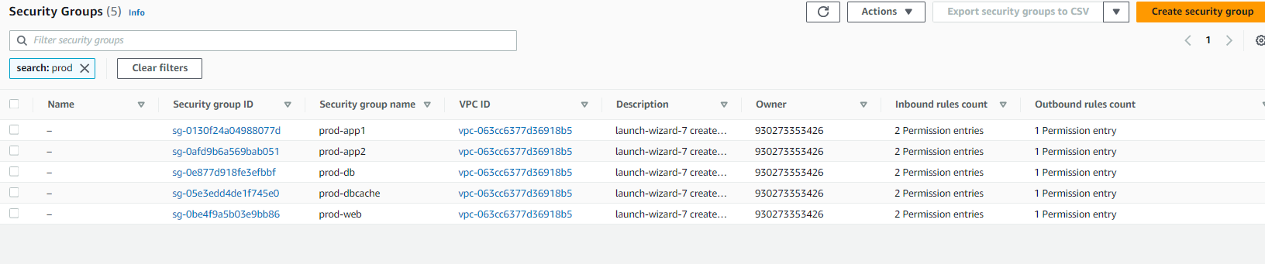

**Development Network:**

1. Design and build 2-tier architecture with two subnets named web and db and launch instances in both subnets and name them as per the subnet names.

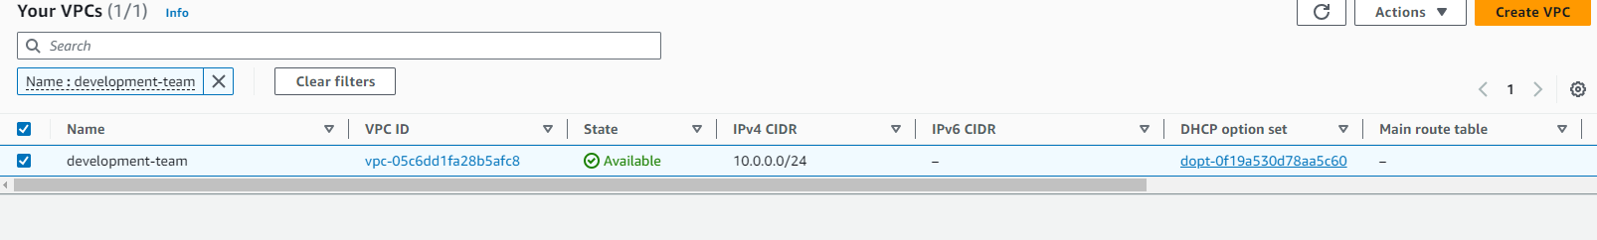

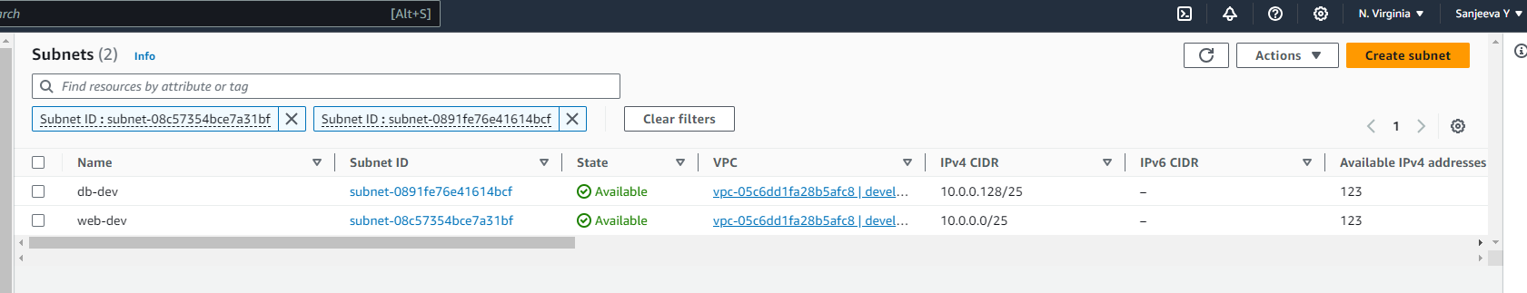

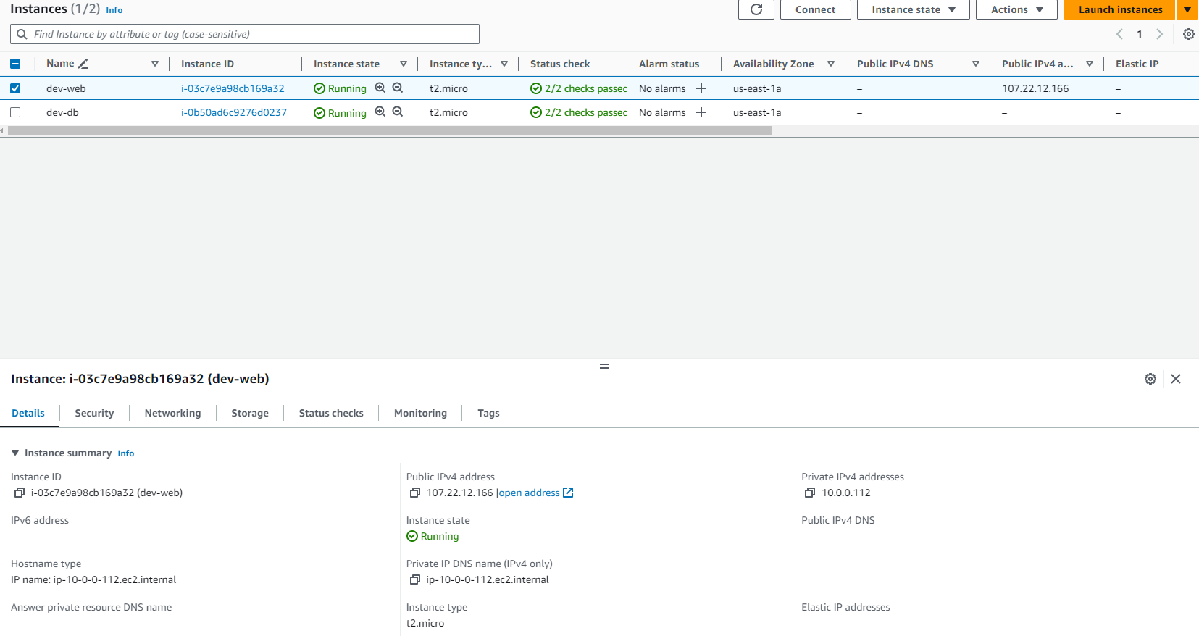

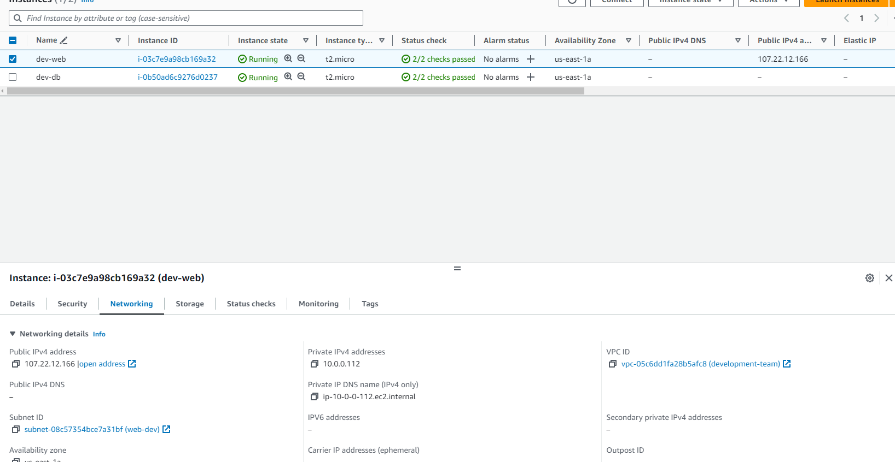

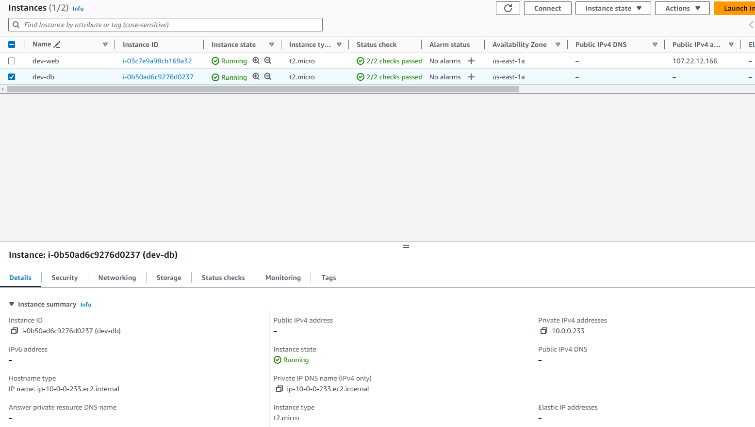

2. Make sure only the web subnet can send internet requests.

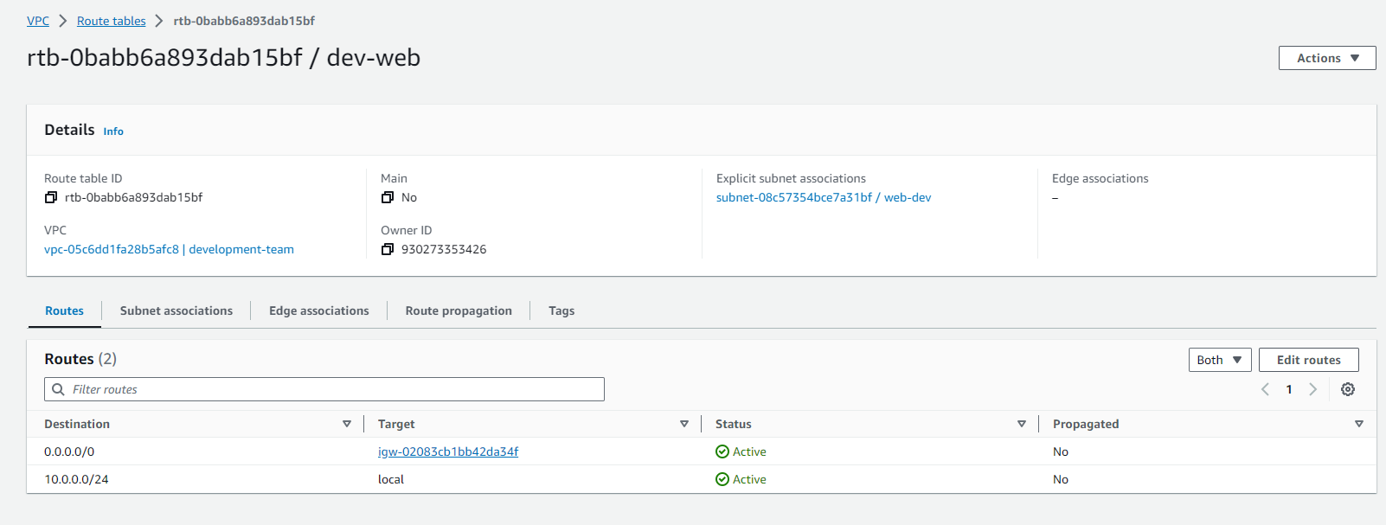

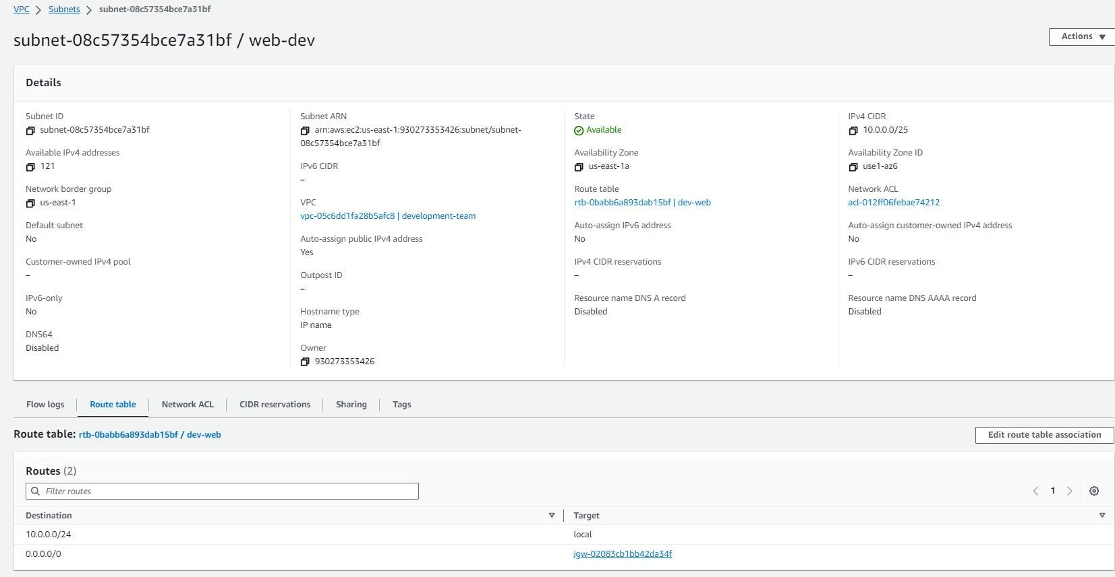

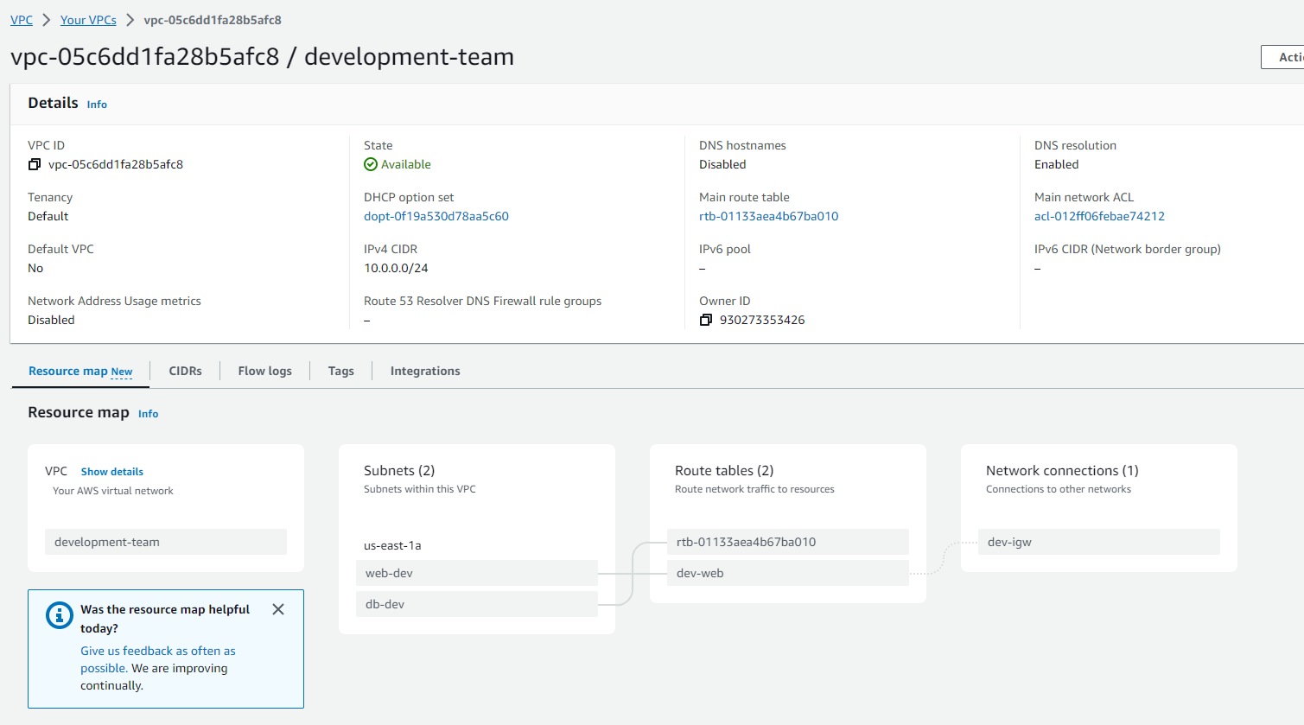

3. Create peering connection between production network and development network.

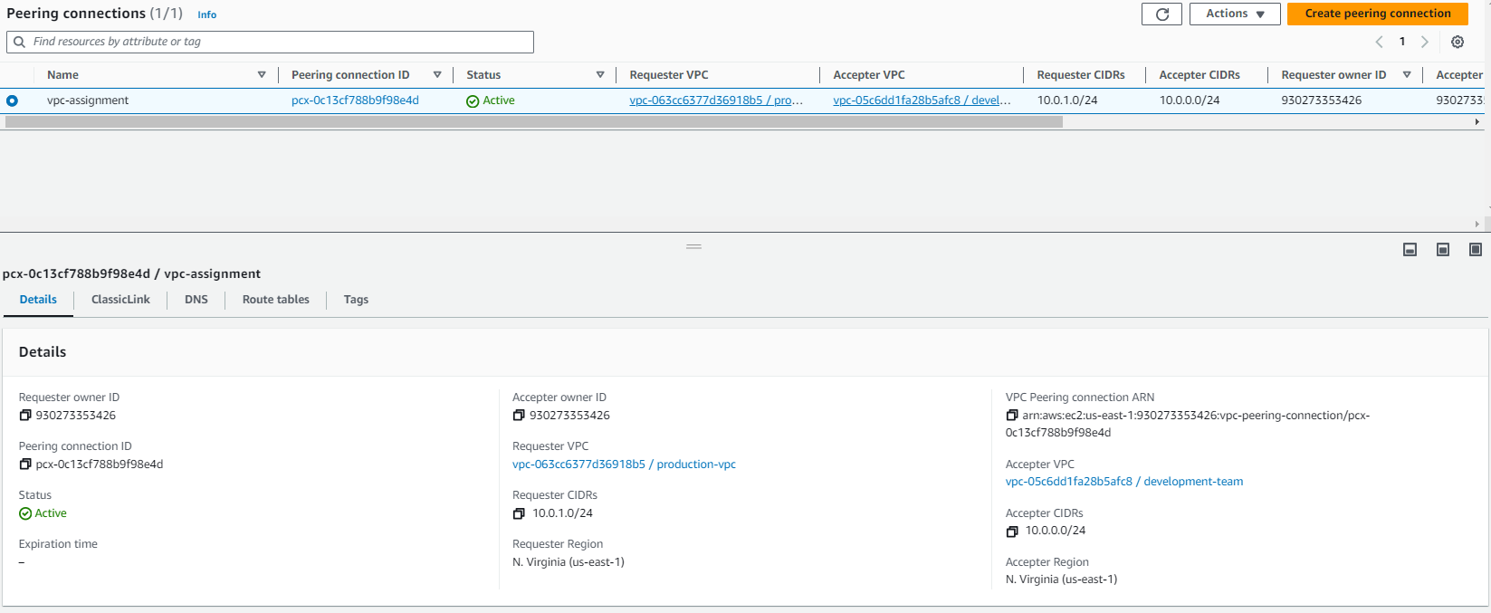

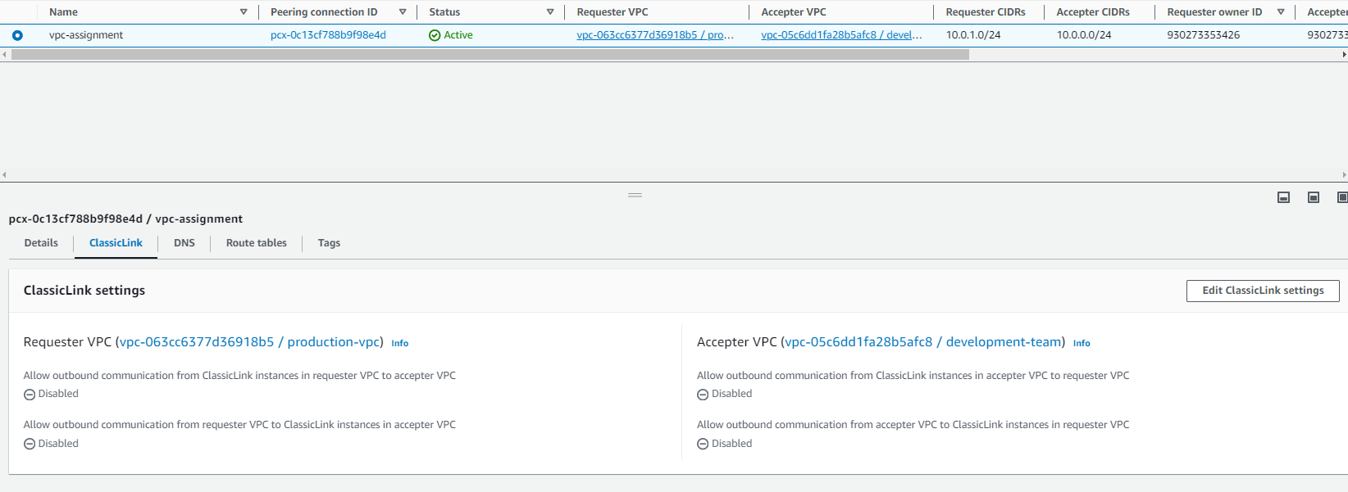

4. Setup connection between db subnets of both production network and development network respectively.

